**Marine Automation using IoT**

**by**

**Kashish 19BCE1760**

**Saransh Vats 19BCE1002**

**Chirag Jajoo 19BCE1738**

A project report submitted to

**Dr. Maheswari R**

**SCHOOL OF COMPUTER SCIENCE AND ENGINEERING**

in partial fulfillment of the requirements for the course of

**ECE3502 IoT Domain Analyst**

in

**B. Tech. COMPUTER SCIENCE AND ENGINEERING**



**Vandalur – Kelambakkam Road**

**Chennai – 600127**

**APRIL 2022**

**Abstract**

An integrated marine automation system is an essential system for safe and efficient operation of ship machinery and auxiliary systems. It ensures that the machinery plant is operating as one functional entity and provides the operators with alarms, controls, status information and analyzing tools. Marine automation systems typically include conventional process control systems, safety systems, vessel management systems, power manager systems, propulsion control systems, dynamic positioning, and other monitoring or control systems. However, more applications like propulsion systems are being integrated into a universal automation system. Marine automation systems have become the most important platform to bridge the gap between or integrate all systems as the backbone of information technology (IT) and operational technology (OT) coverage. At the forefront of digital or connected ships, automation systems are transforming the industry by enabling highly automated repairs and retrofits on new or older ships.

**Index**

|  |  |  |
| --- | --- | --- |
| S. No | Title | Page No. |
| 1. | Abstract | 2 |
| 2. | Introduction | 4 |
| 3. | Literature Survey | 6 |
| 4. | Existing Work | 9 |
| 5. | Proposed Work | 10 |
| 6. | Flow Chart | 11 |
| 7. | Working Modules | 12 |
| 8. | Implementation and Output | 25 |
| 9. | Conclusion | 35 |
| 10. | Future Work | 36 |
| 11. | References | 38 |
| 12. | Annexure (with Sample Code) | 39 |

**Chapter 1**

**Introduction**

Marine automation is simply the concept of maintenance of all the ships or boats visiting a dockyard. In a dockyard the purpose of arrival can be both parking or maintenance and accordingly we have to provide service. With the increased number of ship manufacturers, people with a wish for having a luxurious lifestyle, increased demand for sea transportation, the number of ships is increasing at a very fast rate. Due to all these mentioned factors along with many other factors the usage of ship counters along with several automation features is becoming necessary.

Now there are different types of counters available each using different concepts for calculating the count of ships like some are based on motion detection, some use ultrasonic sensors etc. After maintaining the number of ships there is a mundane task of maintaining the engine health and hardware of the ships. For presenting the prototype of our automation we are using the concept of node red. In node red we are simply showing the prototype how the automations will be working and what are the automations we can have. By bringing these automations we can get many advantages like less need of employees, reduction in total expenditure for running the dockyard, reduced time for servicing / maintaining the ship, no need to check for the parking / service space availability as the counter will help in doing that.

Also, if any work is done by humans, then the probability of error is much higher in comparison to the work done by a machine. So, the main aim for this project is also to avoid the risks / faults which may happen while servicing the ship. The system will ask for some details and based on those details our system will compute what is the condition of the engine, which type of servicing method is required and how much approximate cost you have to pay for implementing the same in your ship. It will also check for the dents and hardware damages which are reported by the ship owner and the details of all the damages will be forwarded to the workers so that all the problems can be rectified. The final approximate expenditure is also calculated and is sent to the owner via mail.

There are many reasons for having efficient and effectively working components for having safe sea travel as having any technical fault in the middle of the ocean can become an issue of major concern. It can take several hours to reach the faulty ship in the middle of the ocean and carry it to the service center so that it can be serviced and the fault can be cured. In worst case scenarios one can lose goods worth billions of dollars and several fatalities can also occur. Sometimes there is nothing which can be done and in result the ship along with all the goods it is having is left to submerge in the ocean and cause water pollution.

In the past several years, many dockyards have faced issues related to space management and delayed service providence. It has become mandatory to solve all these problems. So, by our project we wish to maintain the numbers of ships visiting our dockyard, to reduce the time for servicing a ship and provide the best possible features to the individuals coming to the dockyard and help automate this procedure for reducing the human work to a great extent.

**Chapter 2**

**Literature Survey**

2.1. Comparative Analysis of IoT protocols for a Marine IoT System - M.S. Meera & Sethuraman N Rao

IoT application protocols play an important role in the design and deployment of IoT systems. As the application changes, so does the functionality that the protocol has to provide. In this article, we will install an environmental monitoring station on a fishing vessel to create a marine IoT system. Fishing vessels form OceanNet, a multi-layered P2MP infrastructure network based on coastal base stations connected to the Internet. OceanNet has been successfully deployed in the Arabian Sea from the shore close to the campus. A marine IoT system consists of a sensor network based on a receiver node, a gateway device, and a shore monitoring station. A sensor node can respond to environmental changes in the form of voltage or current. This article presents a detailed comparison of Constrained Application Protocol (CoAP), Advanced Message Queuing Protocol (AMQP), and Message Queuing Telemetry Transfer Protocol (MQTT) for maritime IoT application scenarios.

2.2 Internet of Things in Marine Environment Monitoring: A Review - by Guobao Xu,Yanjun Shi,Xueyan Sun and Weiming Shen

As interest in climate change increases, interest in monitoring the marine environment is growing. In the past few decades, advanced information and communication technologies have been applied to the development of various systems for monitoring the marine environment. Among other things, the Internet of Things (IoT) plays an important role in this area. This article provides an overview of the applications of the Internet of Things in the field of marine environmental monitoring. A brief review of emerging technologies, including advanced big data analytics, and their applications in this area. It also discusses key research challenges and opportunities in this area, including potential applications of the Internet of Things and Big Data to protect the marine environment.

2.3 Innovative Tools for Teaching Marine Robotics, IoT and Control Strategies Since the Primary School - David Scaradozzi, Lorenzo Cesaretti, Laura Screpanti, Daniele Costa,Silvia Zingaretti, Mariantonietta Valzano

The importance of digital technology in education policies of all countries is increasing day by day, and the education system in the era of the 4th industrial revolution faces new challenges. All learners must acquire the necessary knowledge, skills and competencies as individuals determine their chances of succeeding in the future labor market and taking an active role in the future society. Many projects over the past decade have shown that educational robotics (ER) can be a powerful tool for teaching basic STEAM (science, technology, engineering, arts and math) skills and subjects.

2.4 IoT at Sea - Kristian Nybom; Wictor Lund; Sébastien Lafond; Johan Lilius; Jerker Björkqvist; Kalle Suominen

Autonomy in the shipping industry requires the next level of understanding. By reusing IoT concepts, we can meet this need for autonomy. However, IoT systems assume good connectivity. This article discusses issues related to wireless communication between IoT-enabled marine vessels and land base stations. It provides an overview of the use cases and communications requirements that remotely operated autonomous vessels must be able to handle. We also provide preliminary results of field measurements of the waterway conditions of ships cruising the Turku Archipelago in Finland in winter conditions.

2.5 Experimental IoT study on fault detection and preventive apparatus using Node-RED ship's main engine cooling water pump motor - AliSinan Cabuk

The shipping industry is becoming equipped with innovative devices day by day. It is important to monitor all the devices on the ship and to store this data. It is foreseen that IoT technology will be widely used in the near future in ships that are considered to be a factory. In this study, the ship of 4310 Gross Tonnage, an Oil/Chemical Tanker's 5435 HP diesel engine was investigated. The thermal, vibration and current data of the 7.5 kW 3phase induction motor in the cooling pump used for the cooling system of this ship's main engine were analyzed. This data was received from the IoT sensor and sent to the web interface. Monitoring of this data is provided by NodeRED, which is economical and makes it easy to process information received from IoT devices. The system of this study consists of an architecture that receives instantaneous data from the sensor, transmits it to the Internet through an electronic circuit, transmits it to the user through the control panel, and stores this data in MySQL. A system has been developed that monitors the failure of the ship's main engine cooling pump, analyzes this data in real time, and sends an alert before a failure occurs.

**Chapter 3**

**Existing Work**

When we talk about ship automation everyone believes in automation on ship but no one thinks of the automation for maintenance of the ship which is an important part of marine automation which is a field that has not been explored in terms of process automation only the individual processes are automated rather than making complete process automated. There are many existing projects which focus on counting the number of ships in the dockyard, and many projects are also related to making the maintenance processes like putting hardware, machines to remove dents and damages automatically and many other small automations which make the sub-tasks of ship maintenance automatic. But there are not many projects which focus on making the complete task of maintenance automatic. In the counting the number of ships there are several existing approaches available some of them use D-type flip flops circuits and the flip flops state changes after every competition of clock pulse, some uses motion detection to sense whether a ship is going inside or outside, and few are based on the change in frequency as if they sense any major change in change of frequency the accordingly changes the count of the ships. There are several man driven dockyards too where the workers themselves maintain a record of the ships in the dockyard and by manual checking they find the faults and do the maintenance accordingly. There are several other companies like Kawasaki Robotics which are very much ahead in the field of robotics and they have made robots for performing most of the major tasks which are necessary in our industries. Our project will try to utilize the work of these robots by combining it with our automation and in result we can turn the complete process of ship maintenance automatic.

**Chapter 4**

**Proposed Work**

Digitization and automation are transforming the maritime industry. This project presents the design and construction of an automated marine control system. The controller and Arduino, the “master controller,” will be designed and introduced to shipyard vessel counting and will be integrated with software to help maintain a complete vessel record. Based on the sensor interrupt, the system identifies the entry and exit of the vessel as the required type of service. An economical cost-saving system implemented in shipyards that reduces workload by automating things in a much more efficient and simple way.

Here we have discussed the design and working of the Ship counter. The design has three main sections and these include detection section (IR sensor circuitry), alerting section (LCD display and LED) and power supply circuit. The IR sensors are placed at the entrance of the Dockyard; it is placed such that one is present behind the other, that is both the sensors can detect the ship consecutively. The logic behind the working of the counting process is simple: when the ship crosses the sensor near the Dockyard, it recognizes as an increment in count of ships. And when the ship leaves the Dockyard the other sensor senses it and there is decrement in ship count. It is to be noted that both sensors should not be simultaneously detected, so the sensors should be placed apart from each other constricted to the entrance region. The LCD board gets refreshed at every instance as the time delay kept is very small in a few milliseconds so that the count display should not be lagged at any instance. The LED can be connected such that it starts to glow when the ship arrives and stops glowing when the Dockyard is empty. The lighting of the LED is controlled by the Arduino UNO board. If the count of the ship is equal to zero then the LCD displays "No ship in Dockyard!".

**Chapter 5**

**Flow Chart**

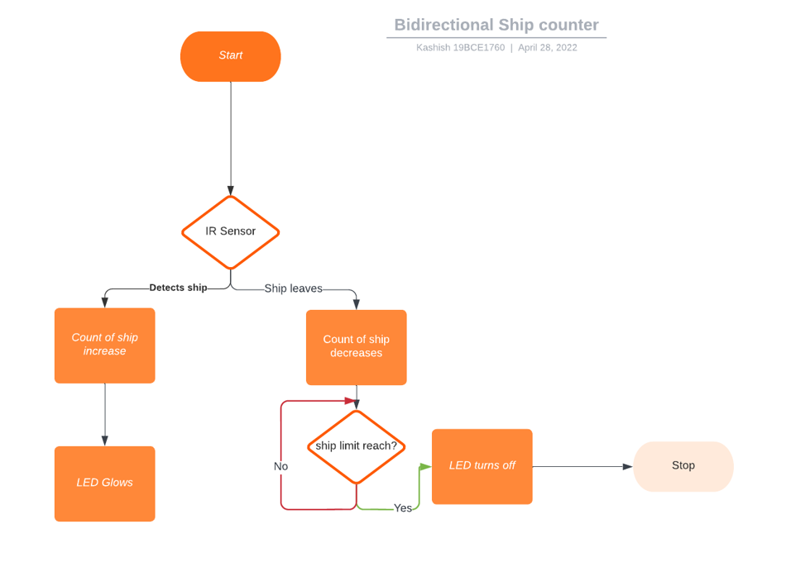

**Chapter 6**

**Working Modules**

**6.1. Hardware:**

We created a ship counter using Arduino UNO. This counter Counts the ships as they enter the Dockyard. After the ship has entered the dockyard, if the LCD display shows the number of the ships as positive then the ships entered are for servicing and if the number of ship decreases i.e., becomes negative then ship entered are for parking purpose only.

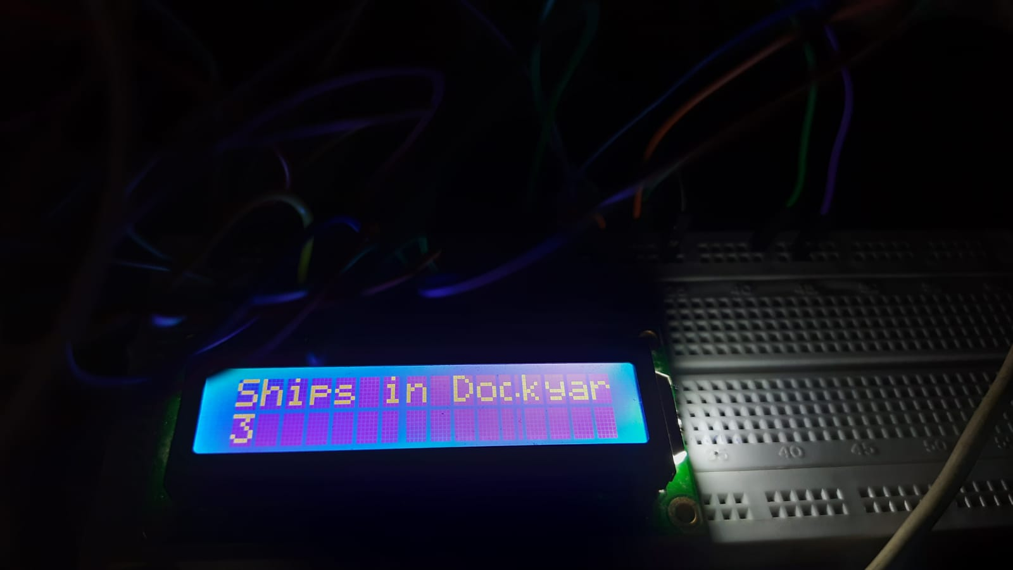

fig 6.1.1. LCD showing positive number which means the ships

are here for servicing

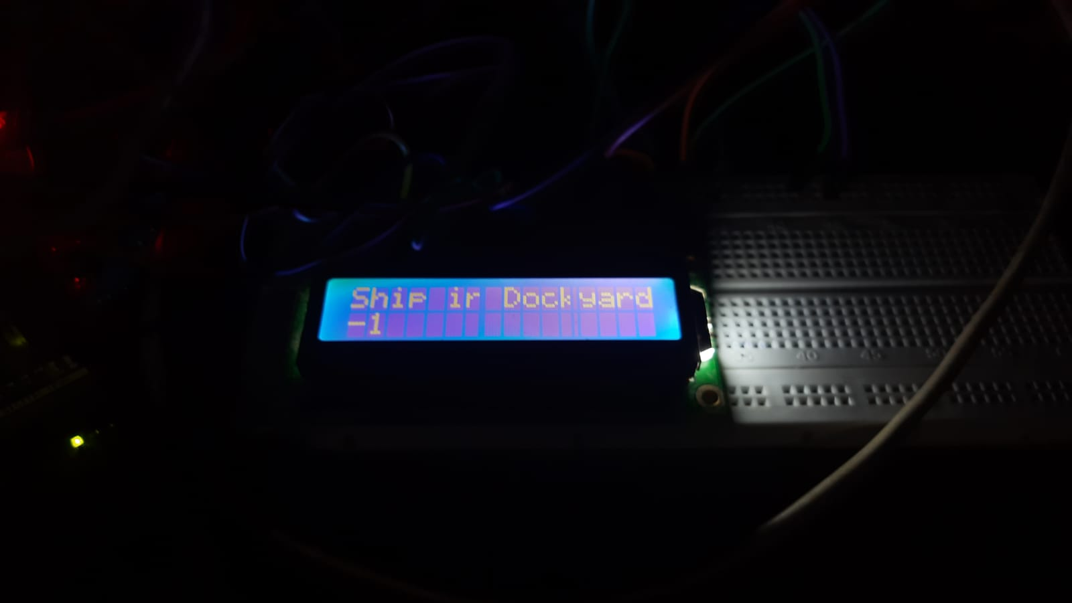

fig 6.1.2. LCD showing negative number which means incoming

ships are for parking purposes only.

**6.2. Software:**

We integrated a node-red stimulation for the ship dockyard where we provide suggestions like which type of maintenance needs to be done like - Condition, Dry Dock, etc. We also calculate the total amount of cost of servicing and cost of Maintenance per mile.

Node-red Flow

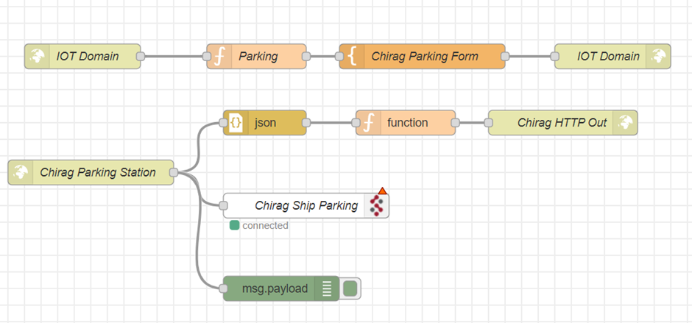

Fred Flow

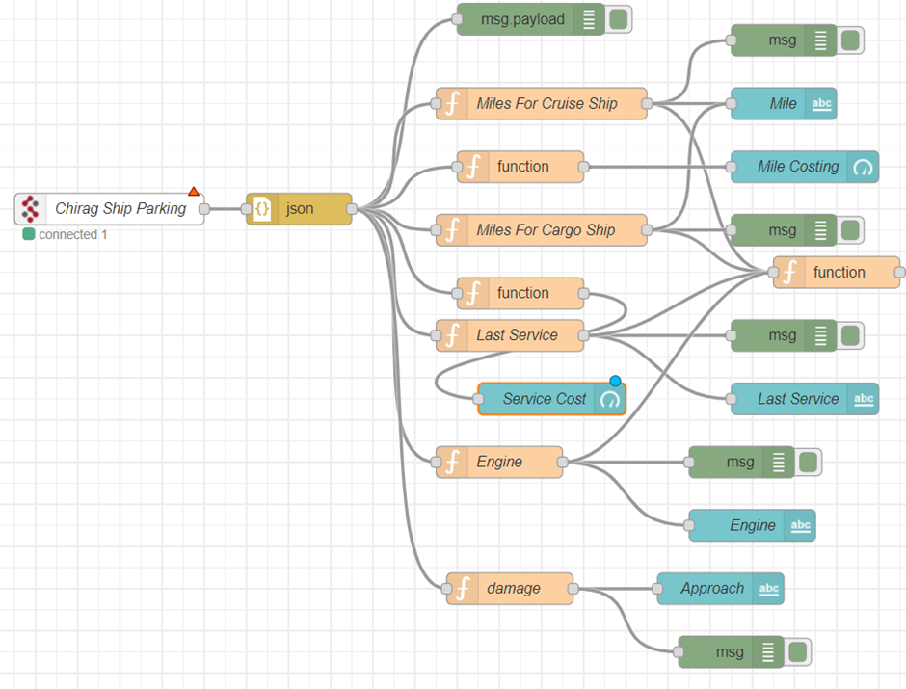

Node-red’s configuration of other nodes

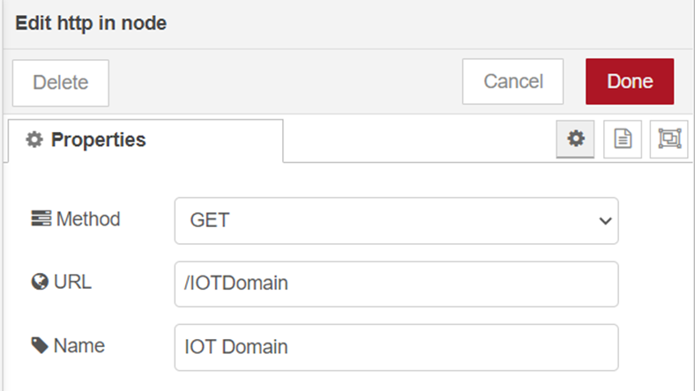

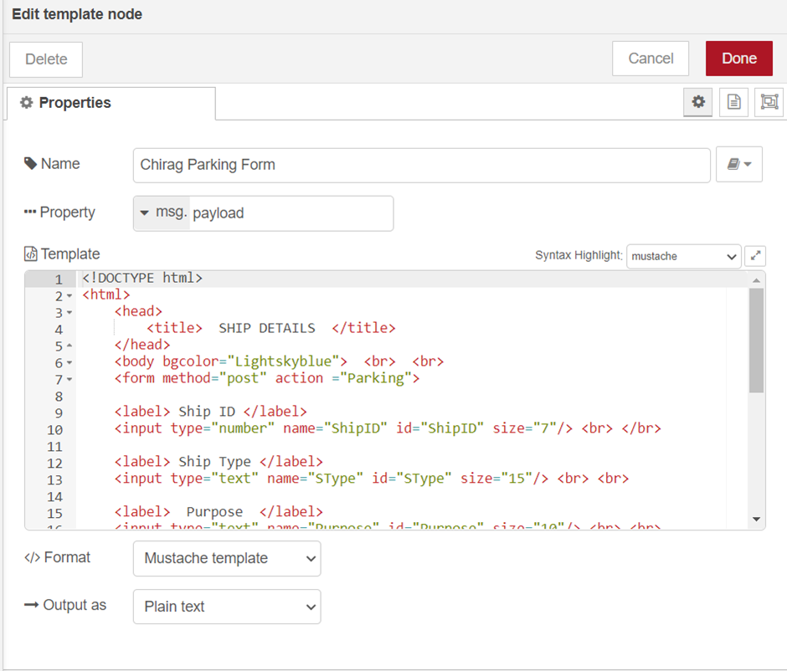

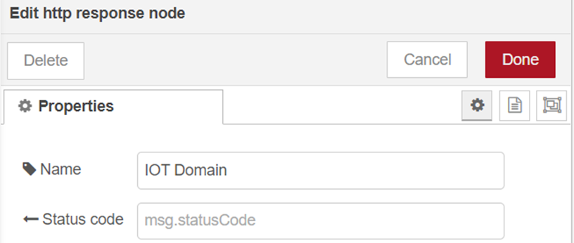

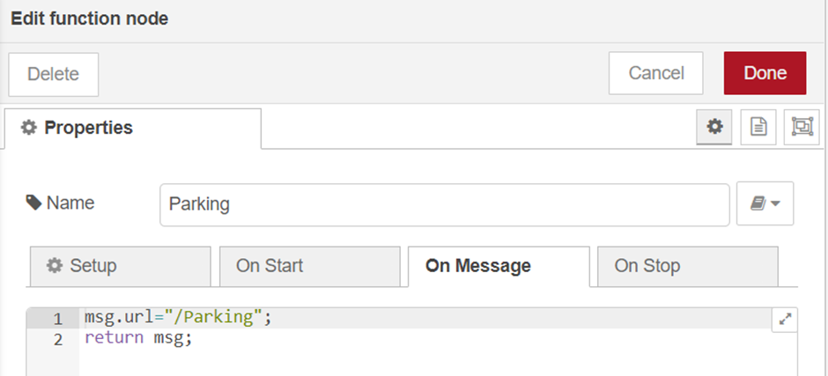

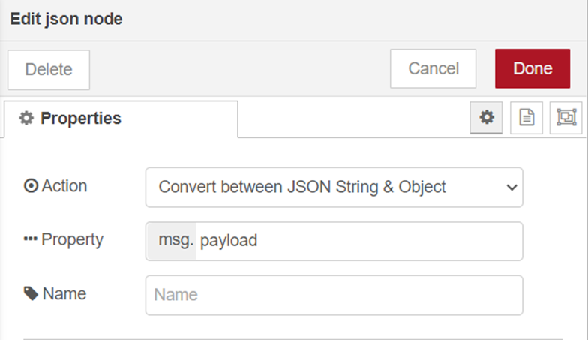

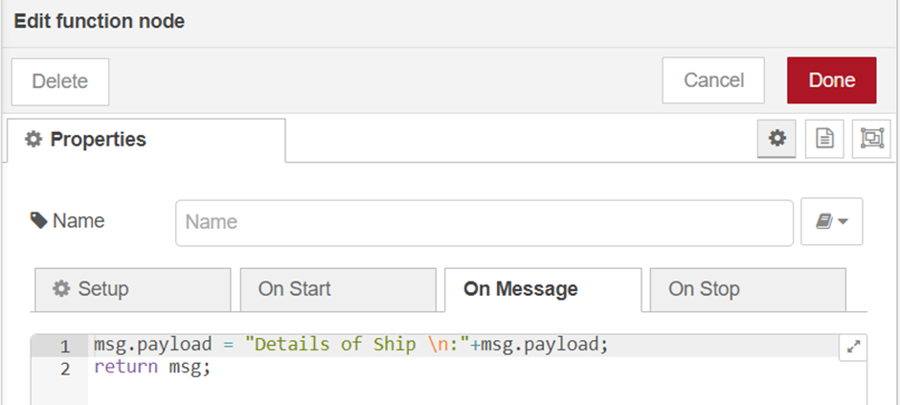

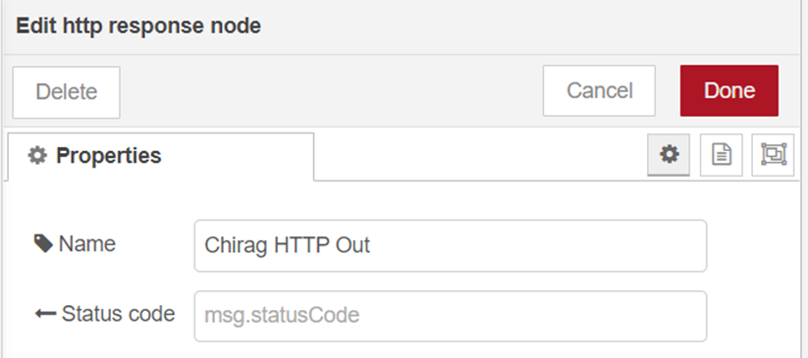

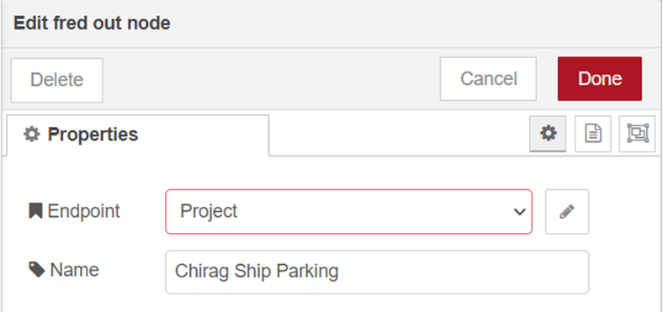

Fred’s configuration of other nodes

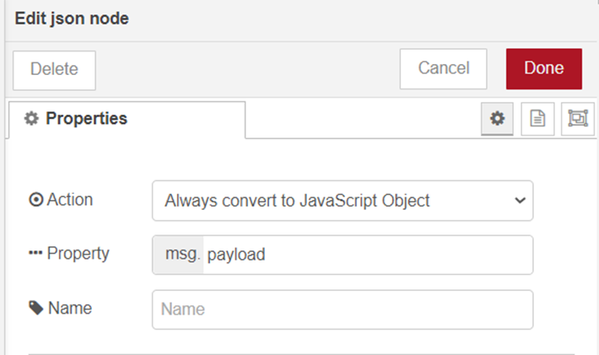

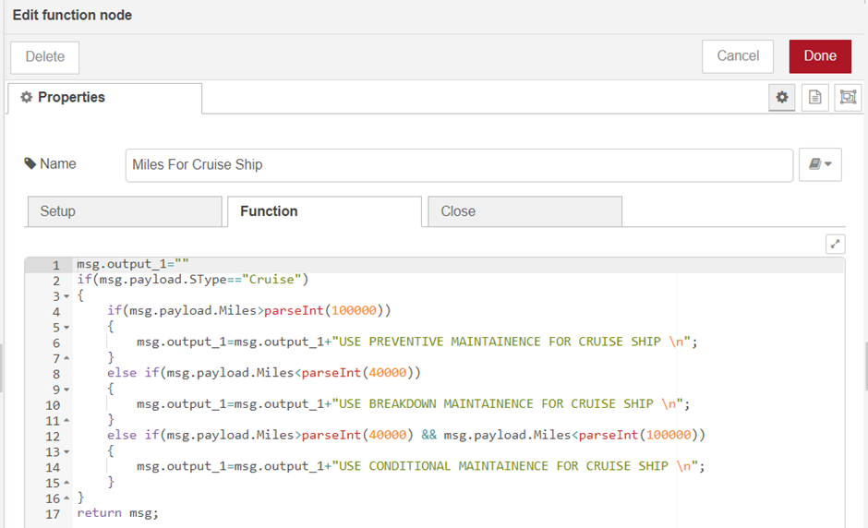

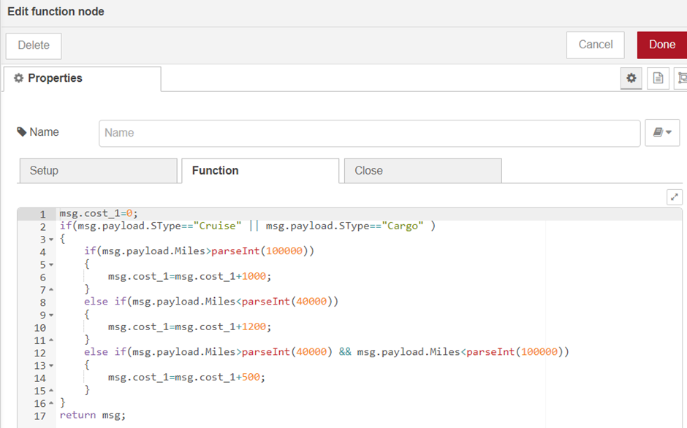

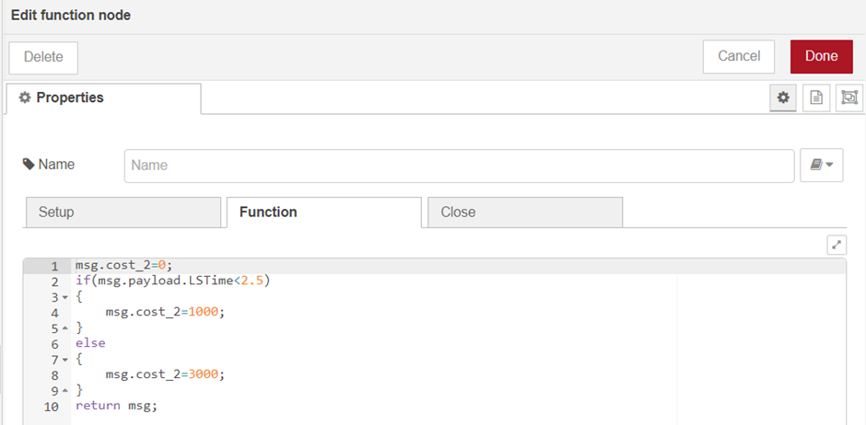

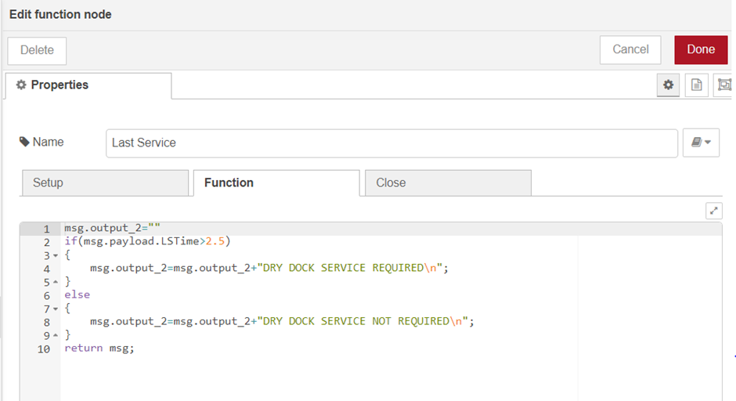

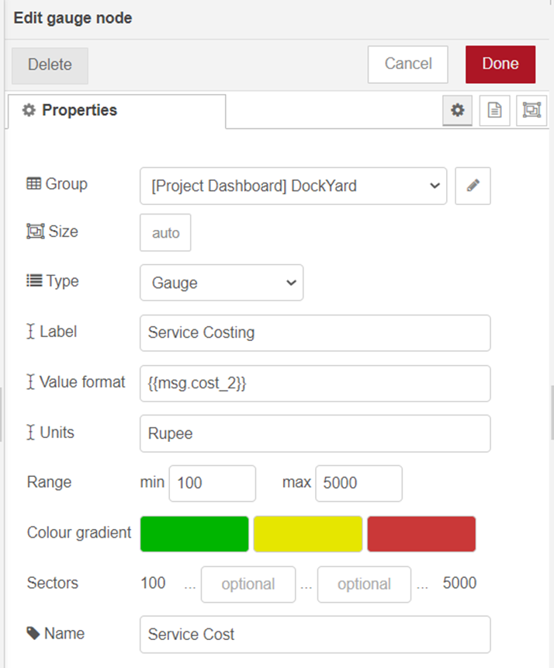

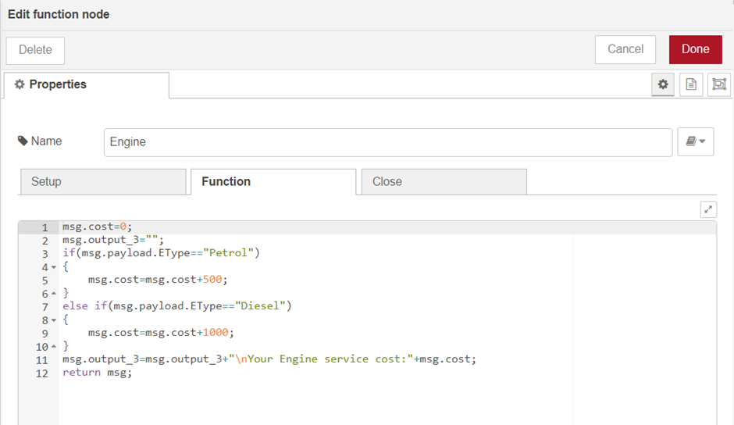

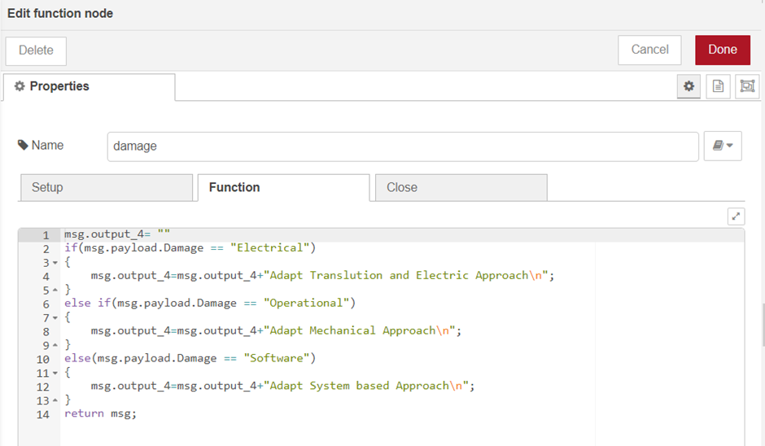

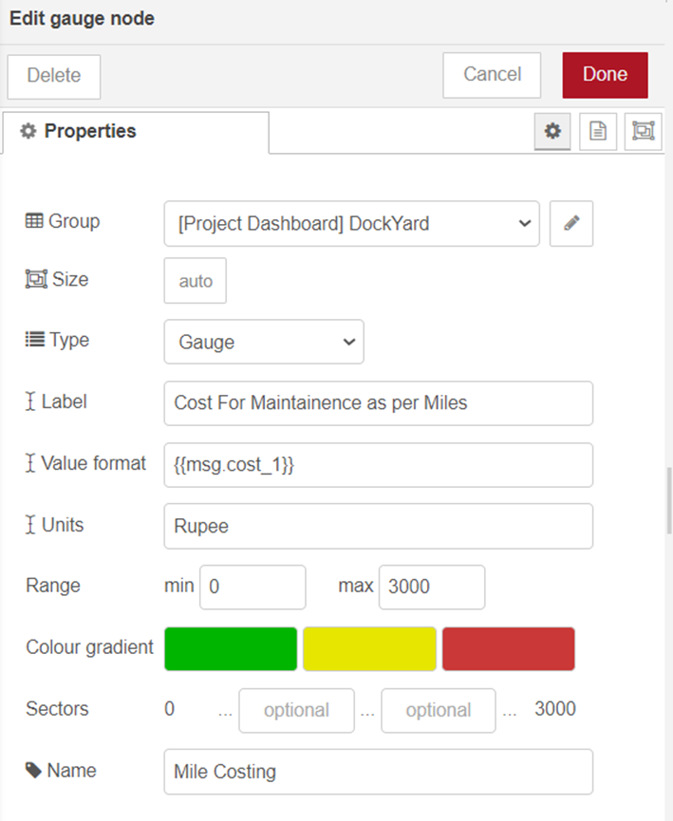

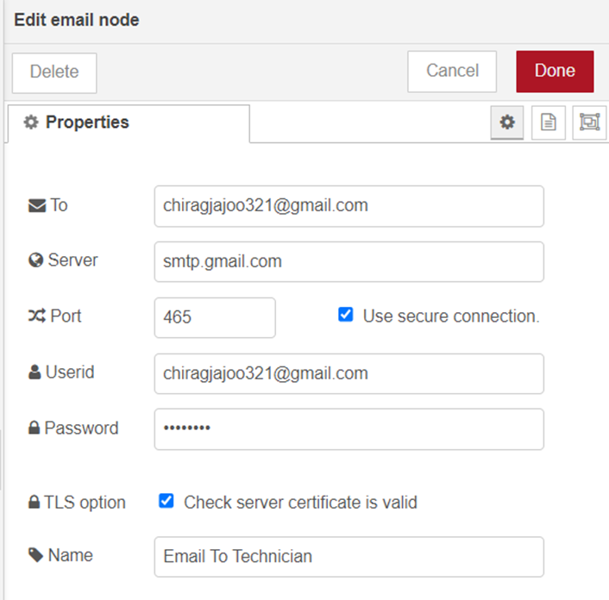

**Chapter 7**

**Implementation & Output**

**7.1. Hardware:**

Video Link: <https://drive.google.com/file/d/1bvpsvIXlkgTIyS_P5r7bNZTdHz3h-C66/view?usp=sharing>

Screenshots:

1. When there are no ships in the Dockyard LCD display shows “No Ships there! Light is OFF” and the LED is not blinking now.

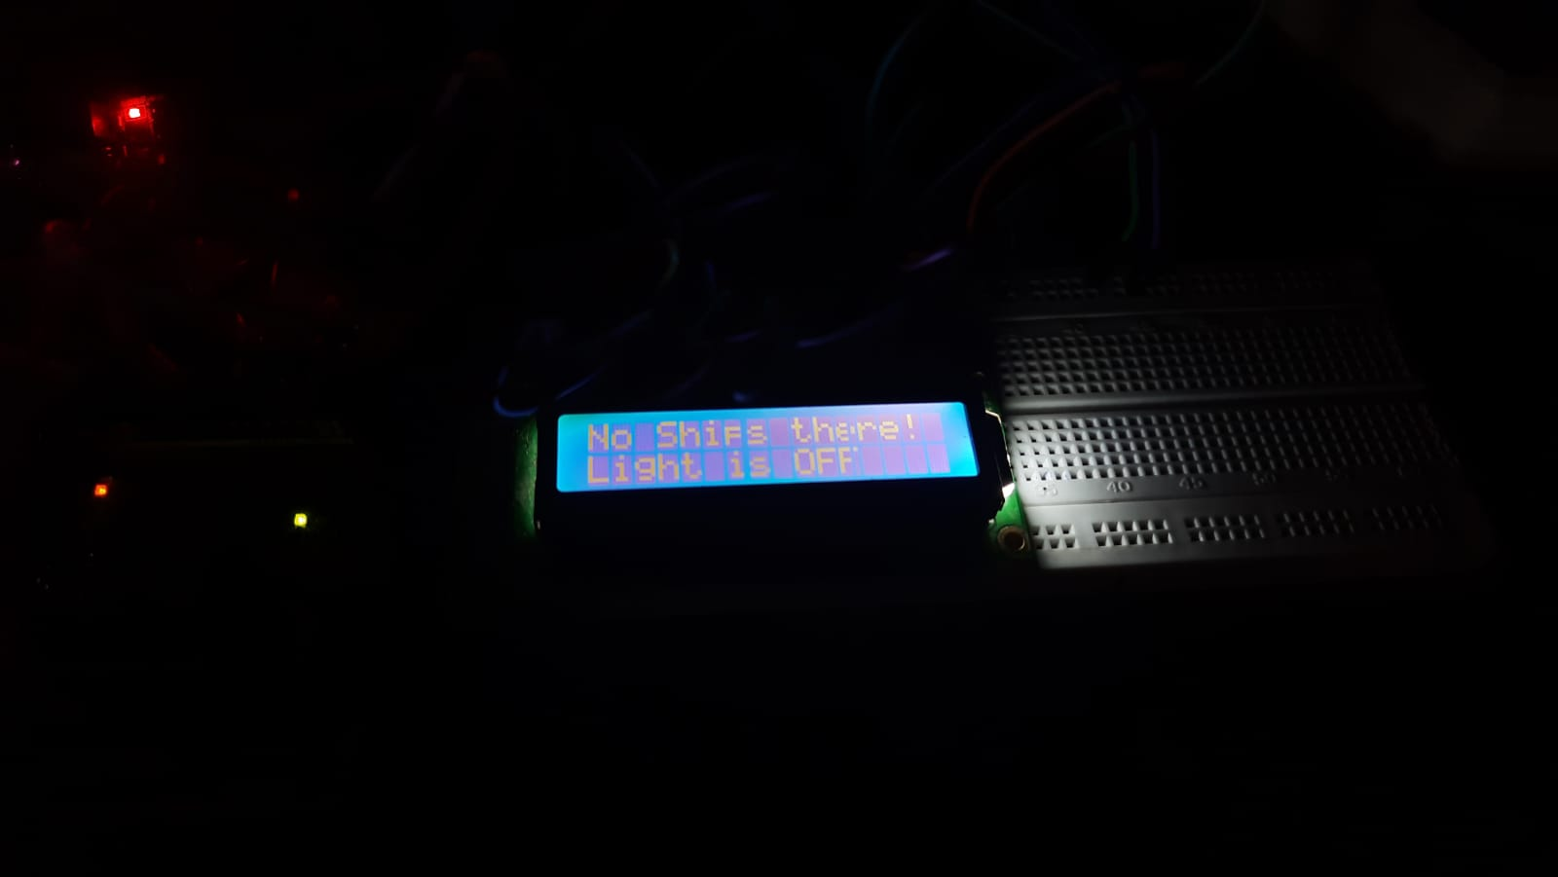

fig 7.1.1

1. When the ship enters the dockyard for servicing then the LCD display shows the positive number.



fig 7.1.2.

1. When the ships enters the Dockyard for parking, the LCD display shows a negative number.



fig 7.1.3

1. When the ship enters the Dockyard, the LED glows.

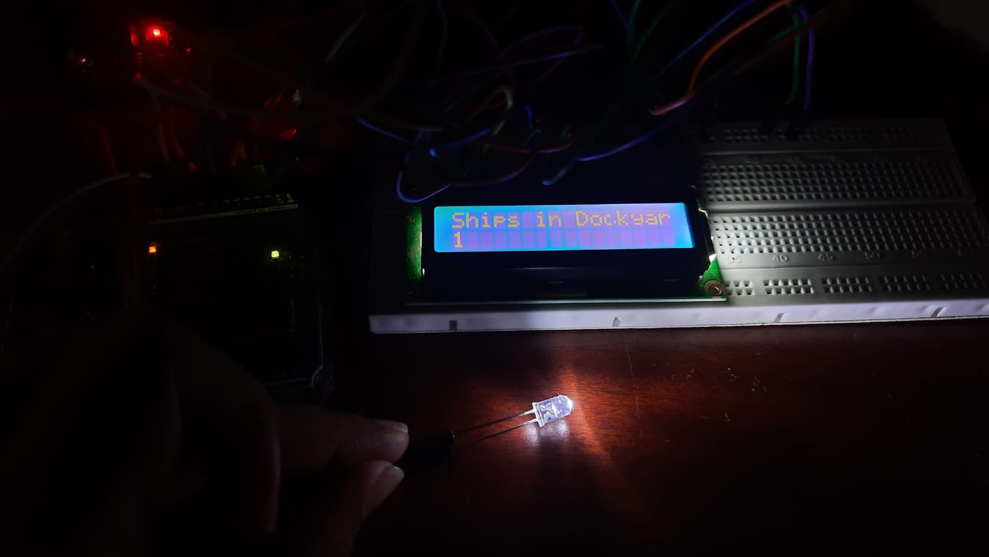

fig 7.1.4

**7.2. Software:**

The output of the Node-red is given below:

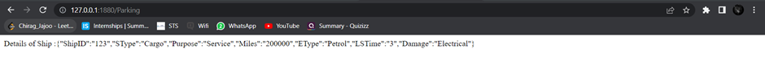

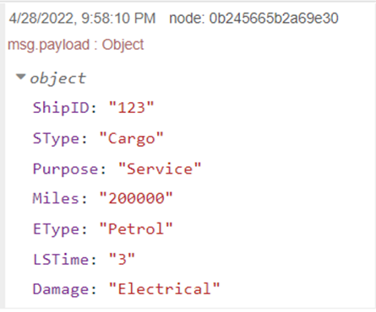

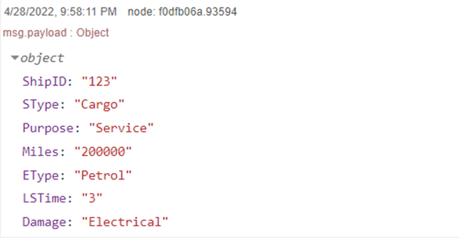

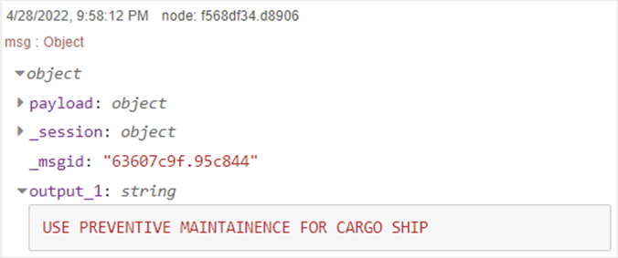

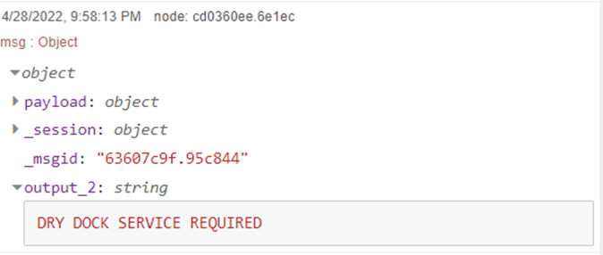

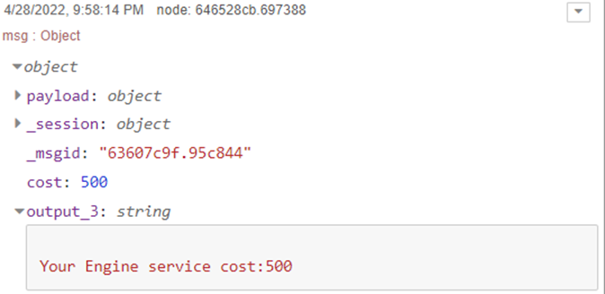

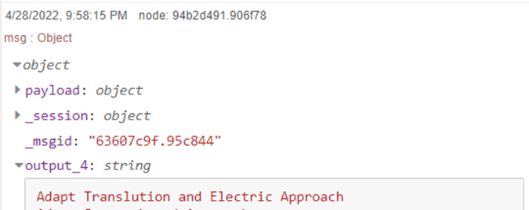

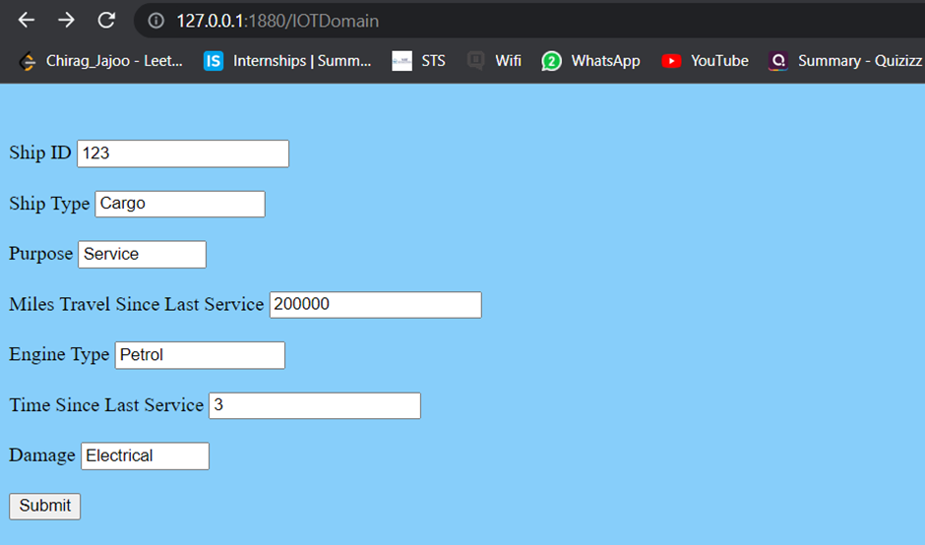

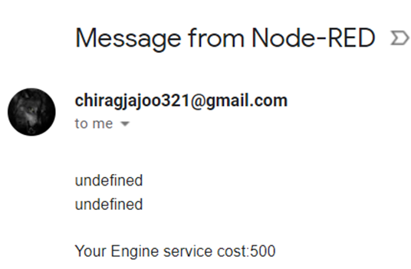

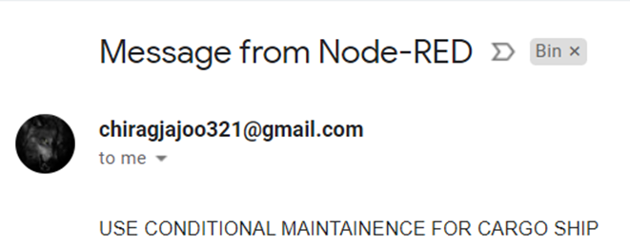

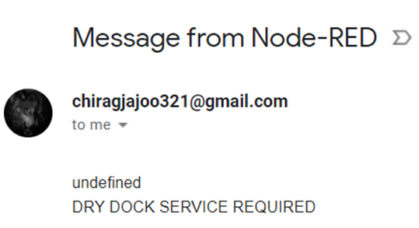

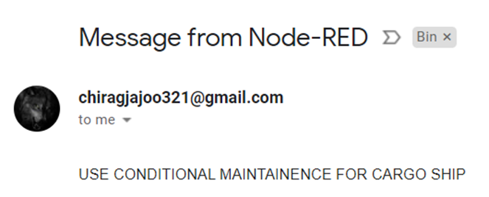

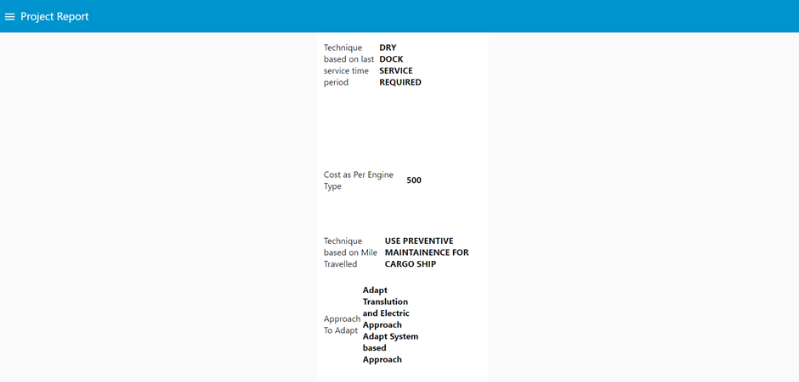

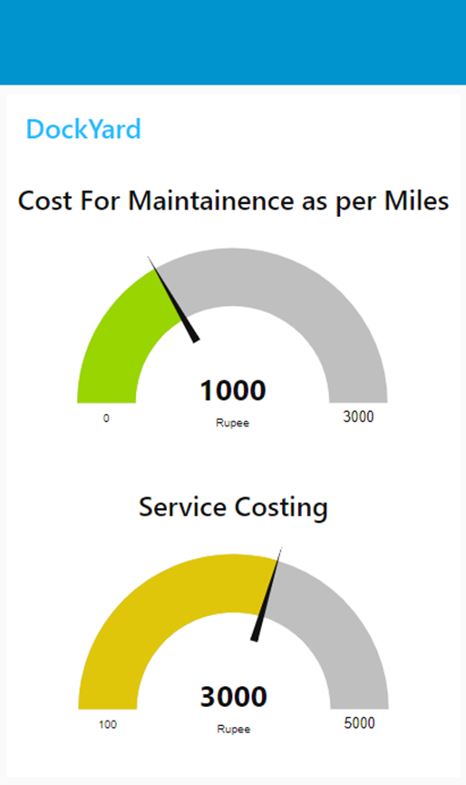

**Chapter 8**

**Conclusion and Future Work**

Here, we have come to the end of the project on the topic Marine Automation using IOT. We tried our best to include all the basic functionalities that are required related to the given topic. We have referred to some books and journals regarding the terminologies and techniques used for maintenance. This project contains automation for Maintenance of ships in the dockyard.

We have implemented and tested the project. Integration, system and unit test cases were developed and the project was successfully tested using these standardized testing methodologies. We have analyzed the scope of the current project implementation and have found it to be extremely useful in real world scenarios. We have also performed analysis on technical and economic feasibility of the project and it was found to be feasible in all the above mentioned aspects.

This project has been developed with minimum cost avoiding all possible unnecessary expenditures, along with this we have made sure that the security of the data transmitted is not compromised.

Our project starts with the detection of the ship in the dockyard as soon as the ship gets detected using the hardware our software automation comes into action. First we are taking the basic and necessary details from the ship captain. These details are then fetched to the server side and all operational functionalities are performed on the server side and based on the input given by the captain our server decides which kind of maintenance technique to be followed, whether he has to implement Dry Dock technique, whether he has to go for electrical damage coverage and many more things.

Our project also sends users an overall report of the maintenance on its mail id and gets an authentication from the user whether to proceed with it or not. It also calculates the overall cost the user has to pay for the maintenance which results in Transparency and builds trust between user and Maintenance Company.

At last it was a wonderful and learning experience for us while working on this project. The joy of working and the thrill involved while tackling the various problems and challenges gave us a feel of the industry. We enjoyed each and every bit of work we had put into this project.

For the future enhancements of this project, we have a few points in mind, some of these were rough thoughts that we got while performing this project, and some are well thought out plans of improvement of this project that we planned to execute, but could not due to financial and time constraints. Let us go over a few of these:

* Designing an AI based software which will analyze the entire ship and make an input matrix on its own rather than taking the input from the user.
* Creating a database based on the input from the software for the company in order to improve their working and to reduce their processing cost.
* Implementing algorithms like Random Forest for getting higher accuracy.
* Implementing a better way to take the input from hardware components rather than taking it based on some assumptions.

We believe that given time, all these points will eventually make it to the market in one form or another. We have made a mark in the sand which would lead others towards these goals and also lead them to many others of their own finally leading towards a better and a safer lifetime for the human species on Earth.

**Chapter 9**

**REFERENCES**

9.1 Comparative Analysis of IoT protocols for a Marine IoT System - M. S. Meera and Sethuraman N. Rao

9.2 Xu, G.; Shi, Y.; Sun, X.; Shen, W. Internet of Things in Marine Environment Monitoring: A Review. Sensors 2019, 19, 1711. https://doi.org/10.3390/s19071711

9.3 David Scaradozzi and Lorenzo Cesaretti and Laura Screpanti and Daniele Costa and Silvia Zingaretti and Mariantonietta Valzano, journal - Smart Learning with Educational Robotics

9.4 K. Nybom et al., "IoT at Sea," 2018 IEEE International Symposium on Broadband Multimedia Systems and Broadcasting (BMSB), 2018, pp. 1-7, doi: 10.1109/BMSB.2018.8436741.

9.5 Ali Sinan Cabuk, Experimental IoT study on fault detection and preventive apparatus using Node-RED ship's main engine cooling water pump motor

**ANNEXURE**

Arduino Code:

(This is prototype, hence we are setting the ship limit to 5 only.)

#include<LiquidCrystal.h>

LiquidCrystal lcd123(2,3,4,5,6,7);

#define in1 8

#define out1 9

#define led1 10

int count1=0;

void setup()

{

lcd123.begin(16,2);

lcd123.print("Ship Counter");

delay(2000);

pinMode(in1, INPUT);

pinMode(out1, INPUT);

pinMode(led123, OUTPUT);

lcd123.clear();

lcd123.print("Ship in Dockyard:");

lcd123.setCursor(0,1);

lcd123.print(count);

}

void loop()

{

int in_value = digitalRead(in);

int out_value = digitalRead(out);

if(in_value == LOW)

{

count1++;

lcd.clear();

lcd.print("Ships in Dockyard:");

lcd.setCursor(0,1);

lcd.print(count);

delay(1000);

}

if(out_value == LOW)

{

count1--;

lcd.clear();

lcd.print("Ship in Dockyard:");

lcd.setCursor(0,1);

lcd.print(count);

delay(1000);

}

if(count1==0)

{

lcd.clear();

digitalWrite(led, LOW);

lcd.clear();

lcd.print("No Ships there!");

lcd.setCursor(0,1);

lcd.print("Light is OFF");

delay(200);

}

//Special case: When the number of ships exceed the limit of 5

if(count1==5)

{

lcd.clear();

lcd.print("Ship Limit Reach");

delay(1000);

}

else

{

digitalWrite(led, HIGH);

}

}